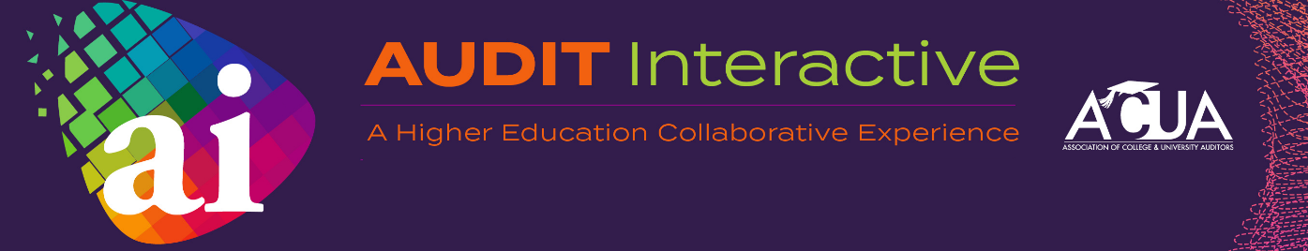

Call for Proposals Guidelines

Please submit completed proposals here.

The deadline to submit a proposal is October 29, 2021 at 5:00 p.m. CST

Preferred Teaching Strategy:
Audit Interactive employs a specific educational expectation model. We ask that speakers divide each of their sessions into three teaching outcomes:
Learn – Attendees will learn the principle definitions, strategies, guidelines for the topic
Apply – Speakers will provide details (tools, references) on how to use this new knowledge in your office
Collaborate – Attendees will work together on a learning exercise (problem solving, case study, role play)

Calling All Experts on Special Topics Identified by the Program Committee:
- Ethics
- IT/Information Security - Privacy, Artificial Intelligence, Bots
- Research – Foreign Influence, Conflicts of Interest, IRB, Animal Care and Human Subjects
- Remote Learning / Remote Work Environments
- CARES Act and HERF funding - Financial Aid, Data Analytics, Expense Reimbursement
- Athletics – Need Based Aid, NIL, Player Safety During Pandemic
- Fraud
- Environmental Health and Safety
- Audit Skills – Intro to Higher Ed, Risk & Planning, Fieldwork, Report Writing, Communications, QAIP
- Emerging Topics – Black Lives Matter, Removal of Historical Statues, Freedom of Speech, #MeToo, Social Media, Diversity & Inclusion

How Long Is Each Session?
Audit Interactive offers two lengths of sessions for deep dives into our topic areas. There are 100-minute and 200-minute sessions. You will request the length of your session. We will do our best to meet all requests, but we reserve the right to make changes as needed to accommodate our conference schedule.

How Will Speakers Be Selected?
The Conference Program Committee is a group of dedicated volunteers range in tenure and expertise in the industry and together form a well-qualified and cohesive work group that will review speaker submissions.

What If I Want To Propose a New Topic Not Outlined by the Committee?
While we consider the speaker submission process a collaborative one, the special topics have been selected after careful consideration. Our members have asked for these topics and we are trying to deliver by pre-setting the topics our attendees need. However, we will consider both “tweaks” to the suggested topics, and other topics not on the list of suggestions, if space permits in the conference schedule.

Do You Have To Be An ACUA Member To Present?
While you do not have to be a member of ACUA to submit a proposal or to present, we are changing the way we select presenters, giving more weight to those that are ACUA members and actively employed in higher education internal audit. You are our experts! If you are a vendor or partner organization who wants to present, preference is given to those who jointly present with an individual who works in higher education internal audit.

What Benefits Are Available To Selected Speakers at Audit Interactive?
- Connect and grow new relationships in higher education internal audit.
- Grow and build your reputation as an industry subject-matter expert.
- Increase your brand and visibility.
- ACUA members receive a discount off full member early bird conference registration fees.*
- See yourself featured on the conference website, in conference materials, on ACUA's social media channels and on the event mobile app.
- Earn extra CPE as a speaker under NASBA standards (up to three times the CPE credits earned by participants).

*If you are not an ACUA member, you will receive a complimentary one-day registration for the day of your presentation.

By submitting a proposal, you are agreeing to the following terms and conditions:
- ACUA will provide a standard audio-visual set-up, prepared for speakers to plug in their laptops.
- Presenters are responsible for all expenses incurred in conjunction with the presentation, including registration, housing and travel. ACUA member speakers will receive a discount off the full member early bird registration rate based upon how many hours they present. Speakers that are not ACUA members will receive a one-day complimentary registration for the day of their presentation.
- Priority is given to proposals that have at least one presenter from an ACUA member institution of higher education.
- Proposals should not be submitted unless each presenter is available to appear on any day of Audit Interactive.
- Presenters must complete a Speaker Agreement in order to confirm their session.
- Presenters must agree to adhere to our code of conduct; this includes no commercial bias on any particular topic, product, service, or company.
- Accepted presenters must use the approved Audit Interactive PowerPoint template.
- ACUA reserves the right to revise presentation titles or edit the session description of selected presentations for ACUA promotional and program publications.

